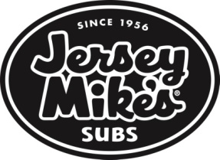

Dear BVFD Friends and Families,
The BURTONSVILLE VOLUNTEER FIRE DEPARTMENT is having a fundraiser, “FIREFIGHTER FRIDAYS!”, at Jersey Mike' on FRIDAY, JULY 21ST.
You may order online, by phone, OR in the store with dine in or carry out. You can order online the day of or even the day before the fundraiser and give them your pick-up time and date of pick up. If you call the order in, make sure to let them know it’s for the “BVFD FUNDRAISER”.
You may also use the APP and even have it delivered. https://www,jerseymikes.com/app
Just make sure when using the APP to put “BVFD” IN THE NOTES.
The fund raiser runs all day on FRIDAY, JULY 21ST from 10am-9pm- so take a break from cooking dinner or go for lunch. Our team appreciates all your support.

Instructions on how to order online are below.

- Go to BURTONSVILLE Jersey Mike's website:
https://www.jerseymikes.com/28029/burtonsville-md 2) Order on THURSDAY, JULY 20TH FOR A JULY 21ST PICK UP OR ORDER ON FRIDAY JULY 20TH FOR SAME DAY PICK UP.
3) In the Checkout section of your order:
- Please put PICK UP DATE/TIME AND YOUR NAME
- Under 'Notes' please put: “BVFD FUNDRAISER”
- Gift cards also count towards the fundraiser. They make great thank you, birthday gifts. Better yet, pick one up for your favorite firefighter!
- “FIREFIGHTER FRIDAYS” IS THE THIRD FRIDAY OF EVERY MONTH THROUGH DECEMBER 2023, SO PLEASE HELP SUPPORT US AND MENTION BVFD THE THIRD FRIDAY OF EVERY MONTH AND HELP US RAISE FUNDS FOR OUR FIRE DEPT.

Thank you for all your support!

